Literature survey
Some Important definitions
Thrust Curve
- A graph representing thrust generated by a rocket motor over time.
- Used to analyse how the motor performs during the burn phase.
Burn Time
- The duration for which the rocket motor produces thrust.
- Determined from the thrust-time data.
Total Impulse
- The total thrust produced over the burn duration.
- Calculated as the area under the thrust-time curve.
Average Thrust
- The average force produced by the motor during the burn period.
- Obtained by dividing total impulse by burn time.
Specific Impulse (Isp)
- A measure of rocket engine efficiency.
- Indicates how effectively propellant generates thrust.
Rocket Flight Simulation
- A computational model that predicts rocket motion using physics equations.
Newton’s Second Law of Motion
- Used to compute rocket acceleration:
- Force = mass × acceleration
Aerodynamic Drag
- The air resistance acting against the rocket during flight.
- Affects velocity and altitude.
Numerical Integration
- A mathematical technique used to calculate velocity and altitude over time from acceleration data.
Data Processing
- Using tools like Python, Pandas, and NumPy to clean, analyze, and manipulate thrust curve datasets.
Data Visualization
- Creating graphs such as thrust vs time, altitude vs time, and velocity vs time using visualization libraries.

System Architecture
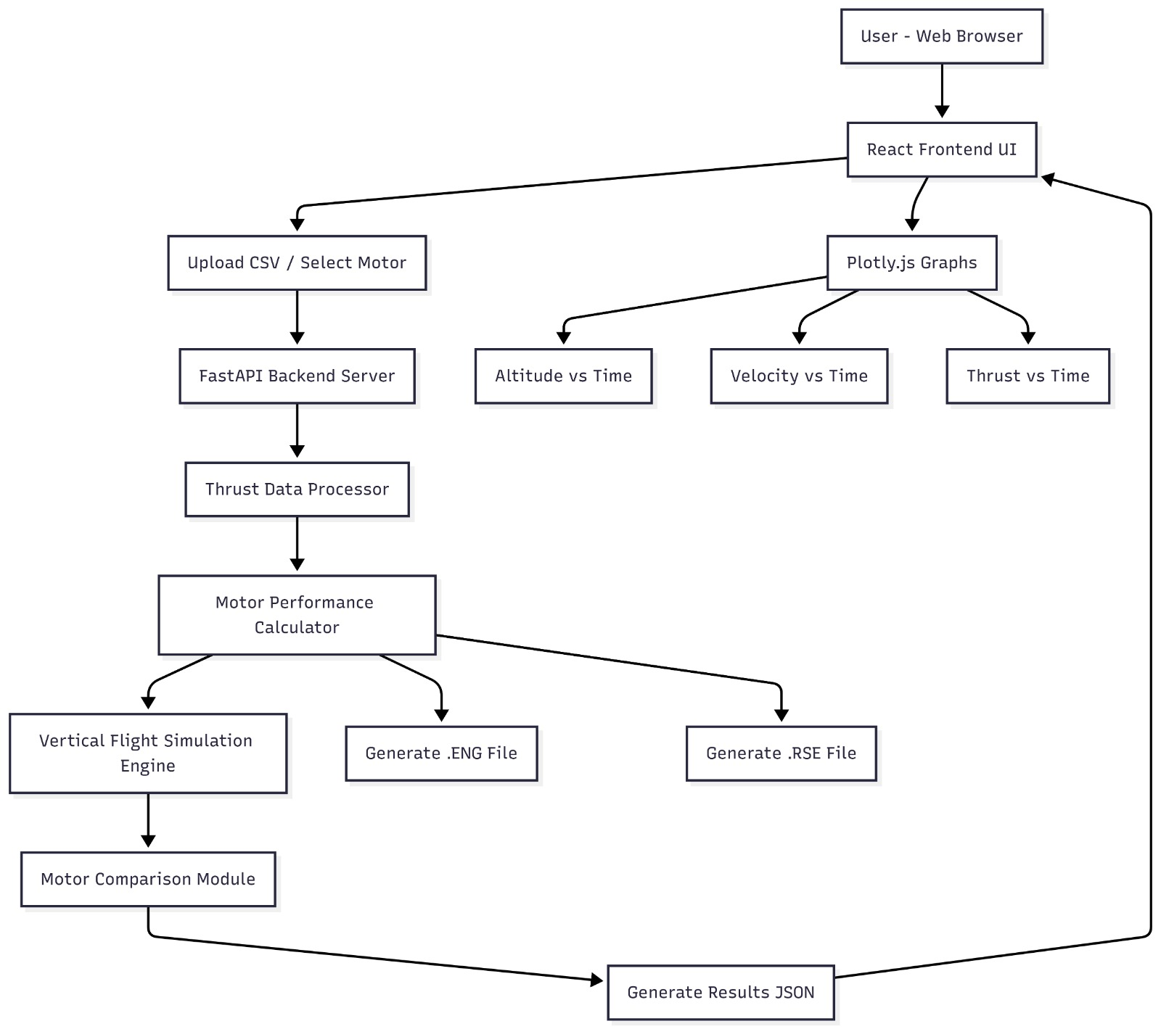

Use of Tools in the Project
- Python is used as the primary programming language for implementing data processing, motor performance calculations, and flight simulation algorithms.
- NumPy is used for performing numerical computations such as calculating total impulse, average thrust, and implementing mathematical operations required in rocket motion equations.
- Pandas is used for reading, validating, and processing thrust curve data from CSV files. It helps in organizing and manipulating time-series data efficiently.
- FastAPI is used to develop the backend API that handles data processing, thrust curve analysis, and simulation requests from the frontend application.
- React.js is used to build the user interface of the system, allowing users to upload thrust curve data, run simulations, and view results interactively.
- Plotly.js is used to create interactive graphs such as thrust vs time, altitude vs time, and velocity vs time, which help visualize rocket motor performance.
- Git and GitHub are used for version control and collaborative development, enabling team members to track changes and manage project code efficiently.
- OpenRocket Motor Standards are used to generate compatible motor files (.ENG and .RSE) so that the analyzed rocket motors can be tested and simulated in the OpenRocket software.
- CSV Data Format is used for storing thrust curve data because it provides a simple and structured way to represent time and thrust values for analysis.

